**GOZHWIT**

**PBL REPORT**

**In**

**SOFTWARE ENGINEERING**

**Submitted as a Course Project**

***by***

**Chava Sai Teja (13BCE1032)**

**Marla Akhil Reddy (13BCE1078)**

**Under the Guidance**

**Prof.Satyarajasekharan K**

**School of Computing Science and Engineering**



**VIT University**

**Chennai- 600 127 – INDIA**

**May 2016**

|  |  |
| --- | --- |
| **Contents**  **Use Case Diagram**  **Class Diagram**  **Sequence diagram** |  |
| **Activity Diagram** |  |
| **Test cases** |  |

Use Case Diagram:

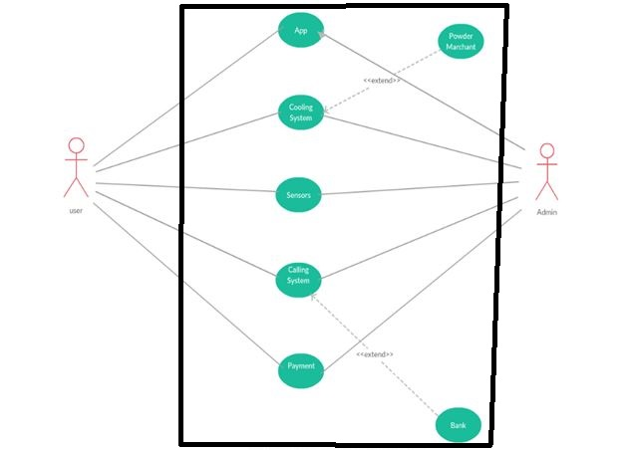

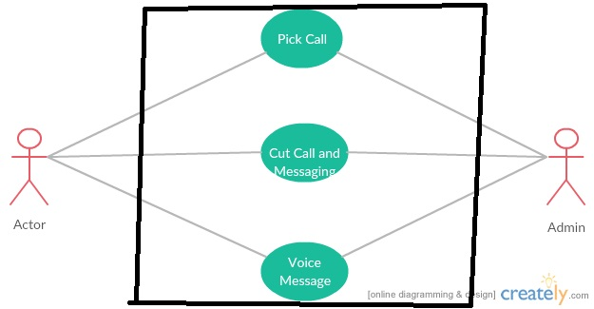

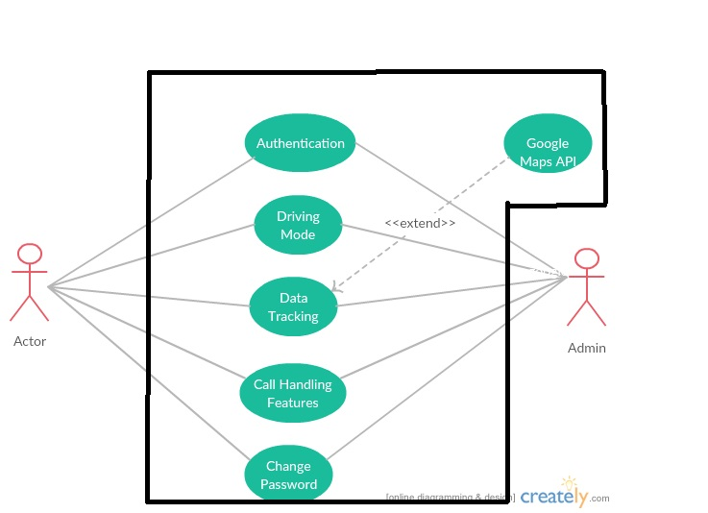

**Sequence diagram(Accident Scenario):-**



**Sequence diagram(Traffic Scenario):-**



**Class Diagram:-**



Activity Diagram:

Activity-1: Traffic Scenario

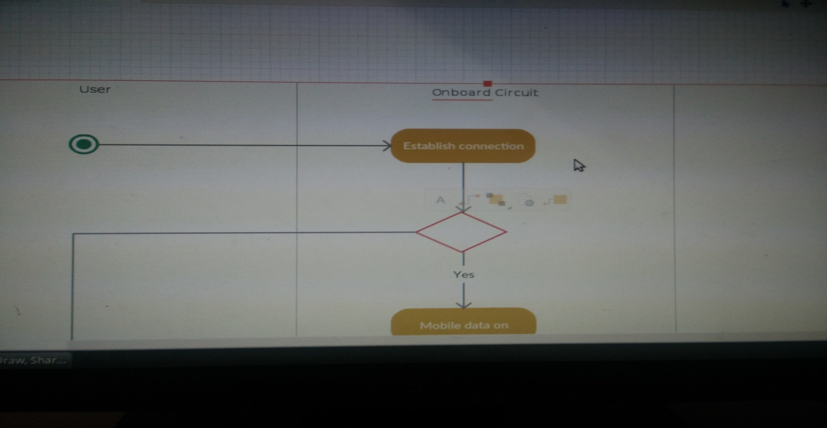

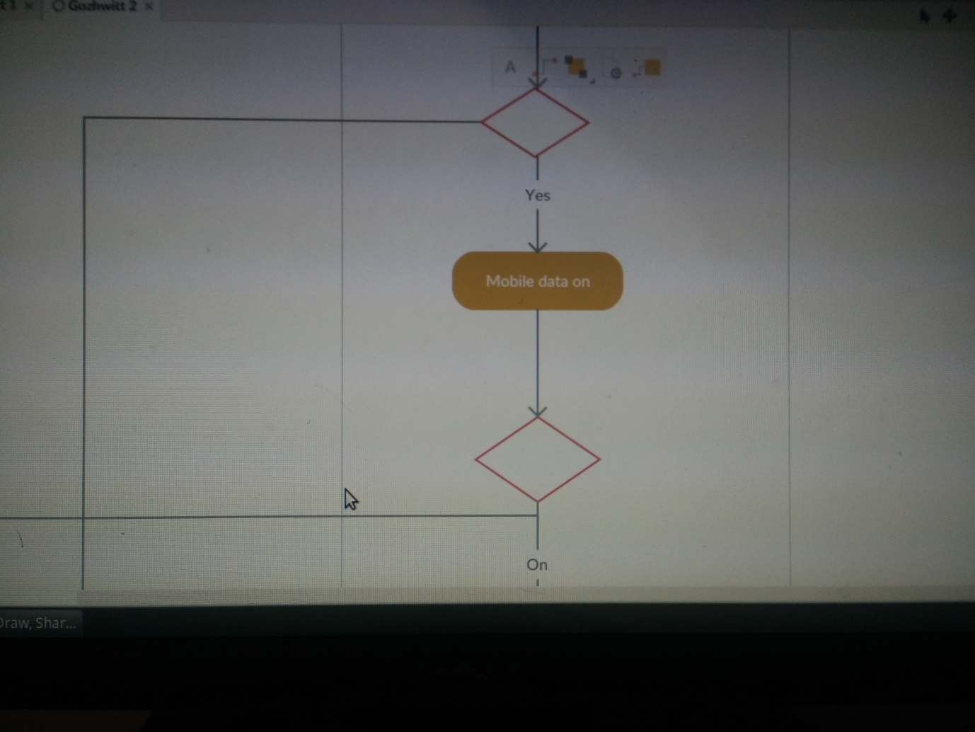

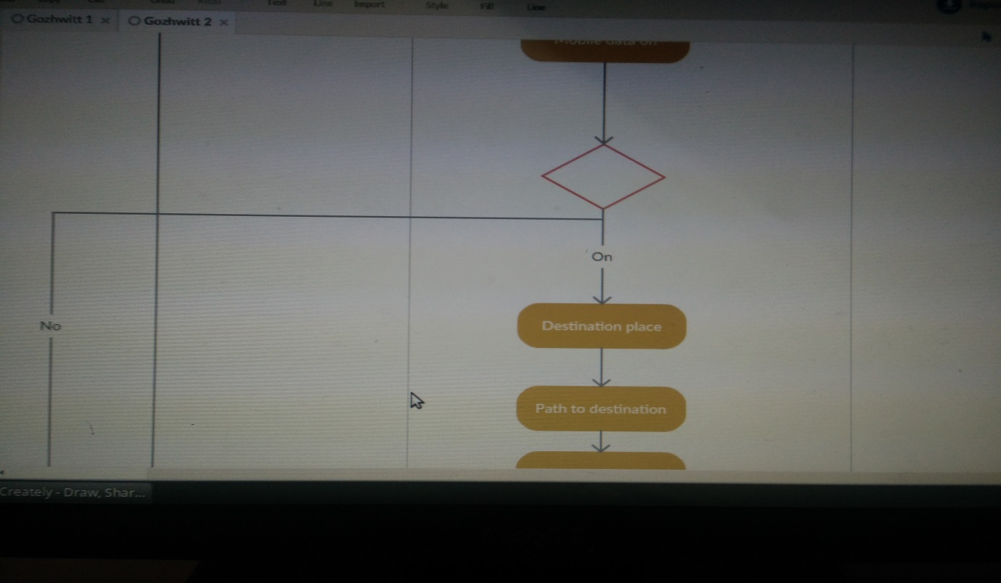

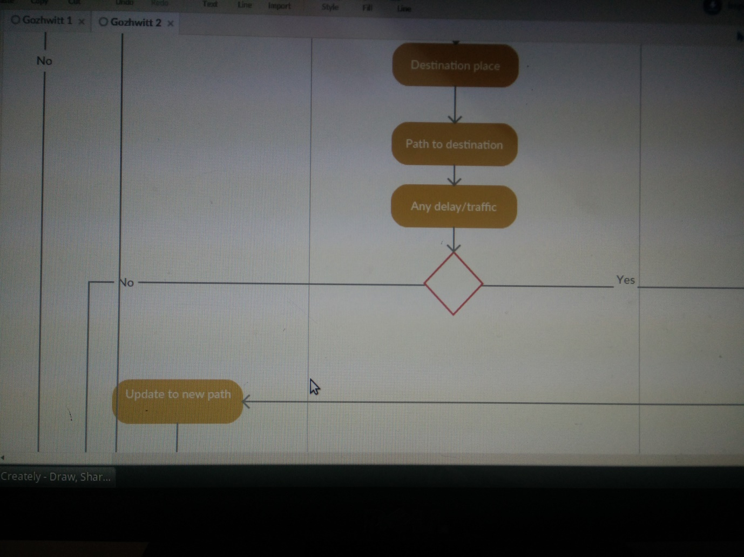

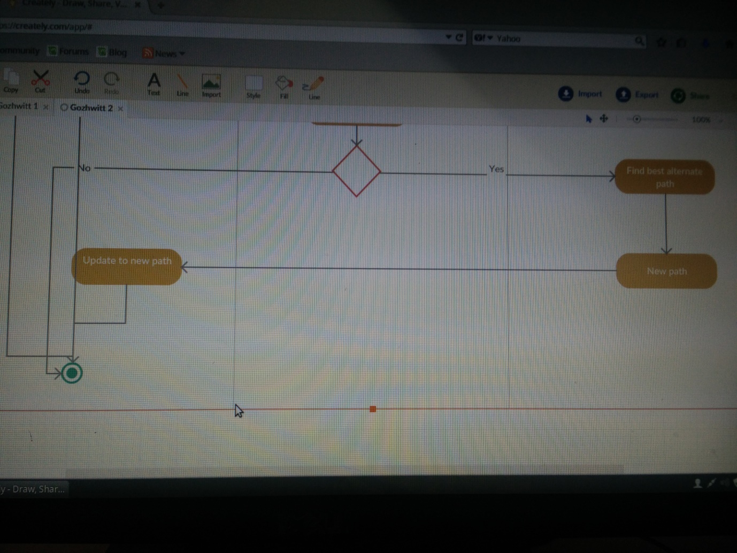

Activity-2: Accident Scenario

